Somnium Documentation

Environment: Orbus Arcanum

Team Members: Chris Fogle, Daniyah Wong, Lauren Casale, Nuha Syed

1. Fill out the table below

|  |  |  |
| --- | --- | --- |
|  | Given Circumstances  (very short description) | Design Objectives  Expand on the description from the given circumstances |
| Time | Night Time | Due to how dark caves are, night time made sense for our dream sequences. We plan to use glowing crystals to provide thematic lighting in our scenes. |
| Period | Renaissance-ish but with crystals | Not as sci-fi in comparison to the ship. Renaissance works in contrast to modern technology. |
| Place | Cave with five chambers | Based on the image sent to us. See image at the bottom of document. |
| Locale | Cave below Venice, Italy | Venice combines the themes of Renaissance and Water |
| Theme | Spirituality, Self-Thought | “This is not Heaven, but rather the space in the mind that deals with questions of divinity” -Somnium Script |
| Mood | Self-Conflict | Each room is the player’s internal debate. |
| Genre | Fantasy/Mystery/Sci-Fi | Fantasy = dreamlike sequences  Mystery = Player is unsure of what is happening to them  Sci-Fi = Screens in crystals |
| Visual style | Lighting changes based on room, Color-coded | Color-coded crystals light up based on rooms completed in the main chamber.  Main chamber has white crystals at first. |
| Solutions for practical problems | Loading/Deleting Assets while player drinks from fountain | The fountain's water changes color to signify what room is next. We can remove and add assets while a player is locked in the drinking animation.  Plan to reuse assets in our dream sequences by simply changing the color of the crystals.  Making sure that things are consistent with the requested environments, consistent with the story |

Architecture setup question - im not sure but it seems like there's a large room, with 5 smaller rooms, and that the hero walks into those rooms. The water fountain, is it just to get into that general area and not more specific places? in that case, maybe we can do that goblet idea to unlock rooms - in order to enter that room, you have to view life a certain way. Take a red goblet, pick up fountain water, fountain water in it turns red - the fountain water is all clear. What happens in life is reality, but what you take from it depends on the lenses you look at it through. angry - red, etc.

Also, it’s a cavern but with pillars and a fountain and chambers and buttresses outside, I think that the inside would look more like a palace than the insifde of a cave.

2. Read through the Somnium script. What will be needed in your level to support the NPCs and the player?

• Interaction

* drink from the fountain

o Button presses, things to read, etc.

* Red room: interacting with swords, people, treasure, etc., how you can hurt yourself and other people with your emotions
* Yellow room: swatting away at bird as they are falling
* Green room: interact with rocks, if startled by noise, throw something at it; maybe at the end of the time for the experience, it starts screaming, water fountain starts, player automatically rushes to drink water, no choice? Fear can control you shown by how the player has no choice but to leave when terrified?
* Blue room: picking up seashells
* Violet room: picking up crystals and looking into them
* -when interactions are done, water in the fountain starts flowing again and crystals turn back to white?

• Particle effects

* Water splashing out of fountain (main room)
* Water splashing in ocean sequence (blue room).
* Leaves falling and wind moving through trees in the green room.
* Blood splatter in the red room if you decide to attack a cutout with the sword. Sparks flying off swords
* Yellow clouds for the yellow room.
* Glowing crystals in the violet room. Glitter type of effect. Magical Sparkles~!

• Camera effects and transitions

* Fading colors/ light

• How does the player get from one scene to another?

* Player drinks from fountain, crystal colors fade out, new colors fade in

3. Image Research

Add screenshots with links to images that will inspire your environment. Consider:

• How does my environment evoke the time period? Genre? Time of day? Etc.

• How will I connect my environment to the themes of the work?

• What will objects in the space look like?

a. List at least 5 images for the environment as a whole + links

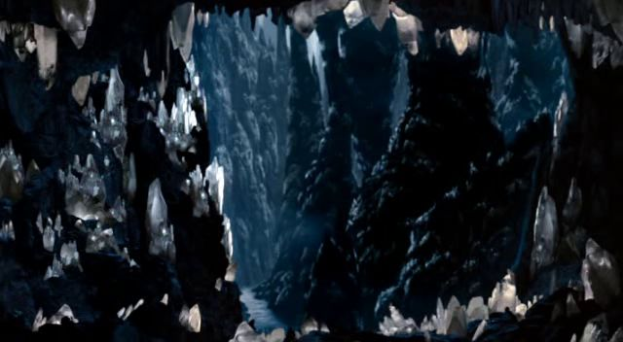

Main room- White crystals with a dark cave

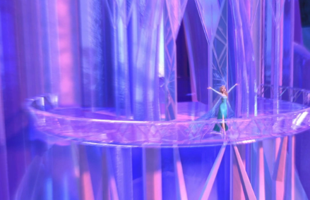

Architecture and colors example for a crystal structure with a castle-related appearance

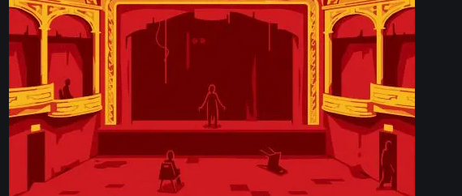

Red room - War, battle, treasures - theater for a play, props look real but some swords/coins are real, some are fake, treasure chest, maybe the other people the hero has met are cardboard cutouts? Can interact with them based on their previous interactions, maybe? Possibly to show some victories aren’t real, some fights not worth it? Maybe flowers thrown, looking for validation?

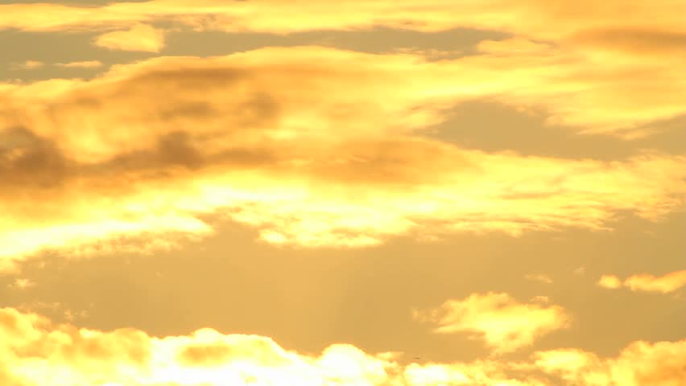Yellow room - Falling/ flying in the sky, adrenaline based, yellow glow, bird surrounding/circling to add fear factor and pressure

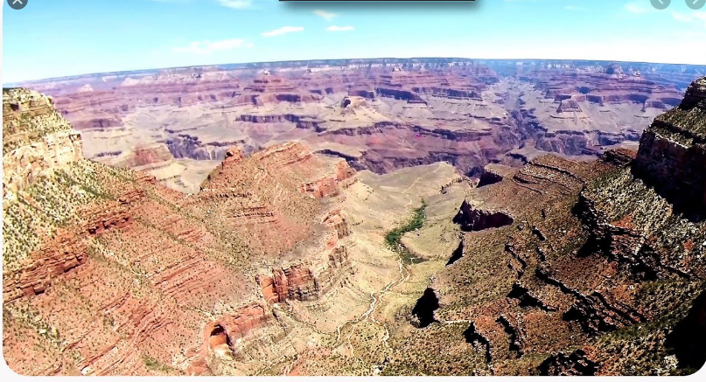

What about flying through a yellowish-colored canyon? All the rocks would seem new/to have differences as you flew by, can dive into the greater canyon and go between rocks like in those movies where it’s like ‘a hard maneuver’ and a tight fit but it gets through, maybe it can be following a bird that’s going fast, diving and twisting to fit into spaces, as hero follows it, it’s exciting and scary to go through new things and to face things you feel like are daunting or you might not get through well, but when you do, it’s exhilarating. Particle effects outside the room can be the wind blowing some dust out of the door.

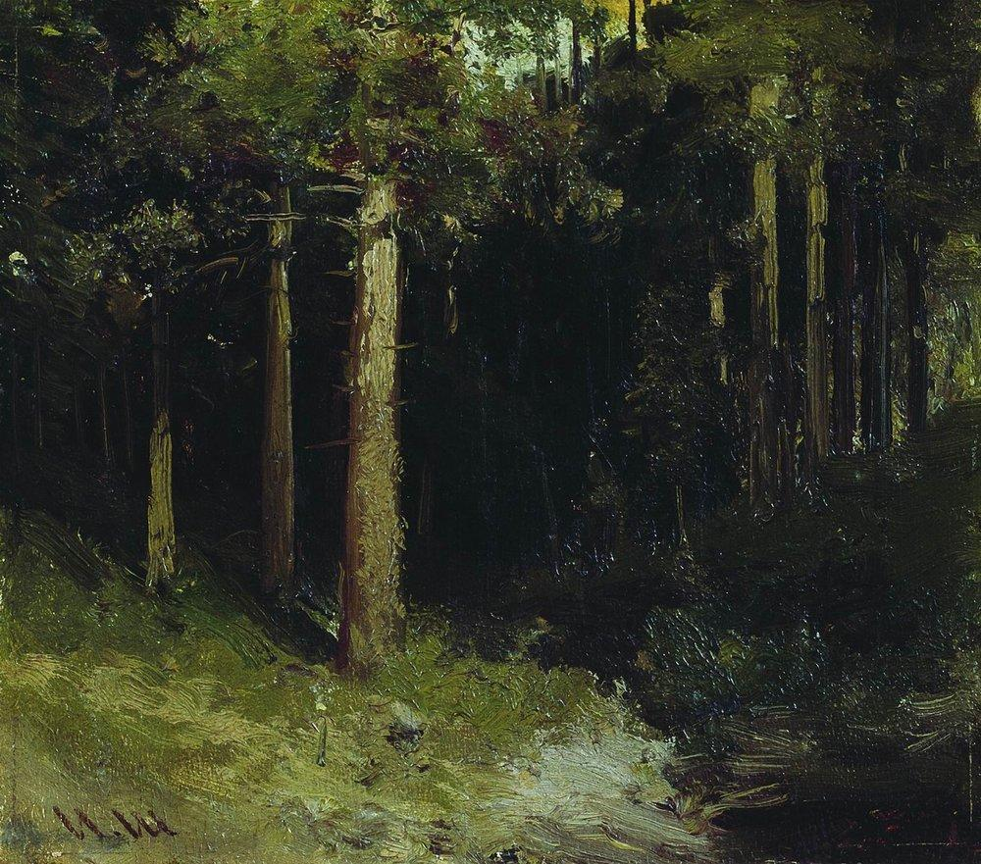

Green room- The green room plays on the idea of fear. Tall trees and dimly lit woods give the player a feeling of suspense. Potential adding sound effects to add paranoia, sometimes an intense rustle of bushes/plants moving around in lines in the distance as if something fast was circling you and watching

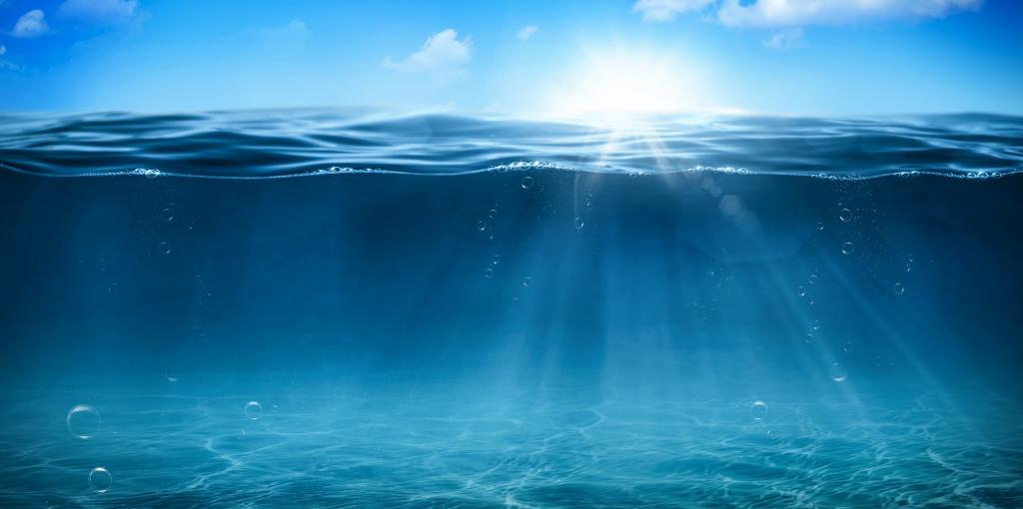

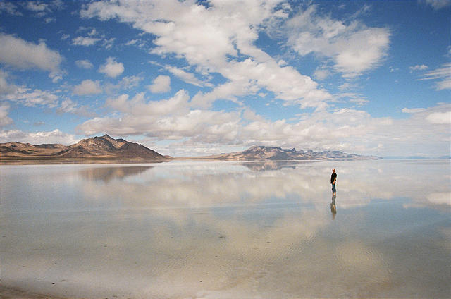

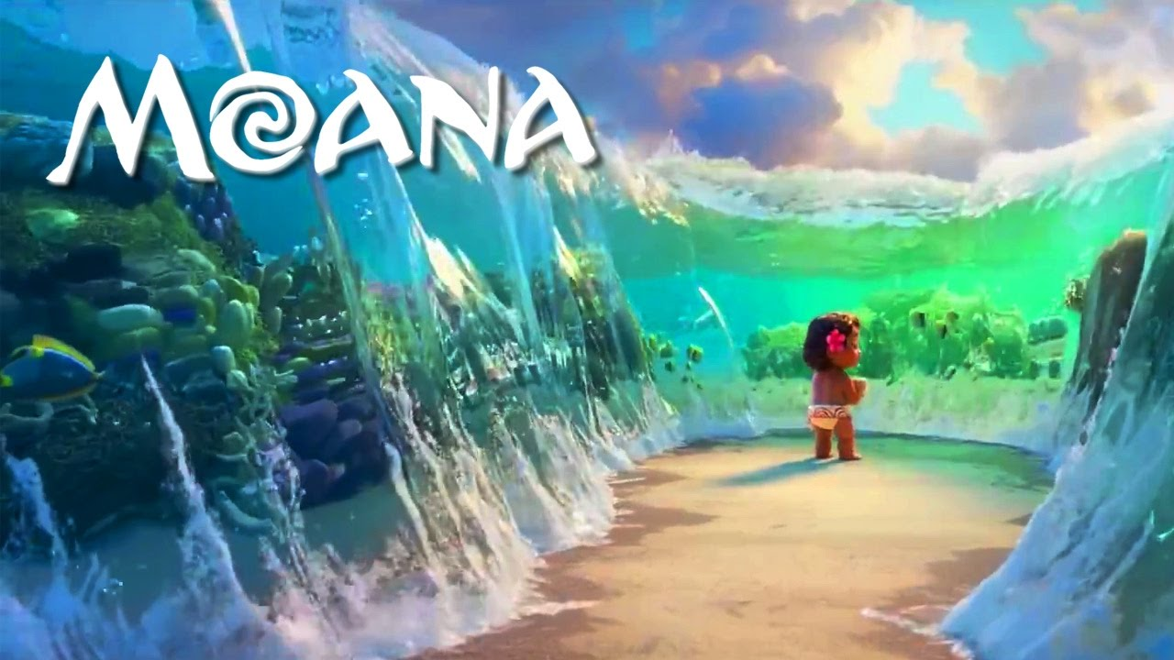

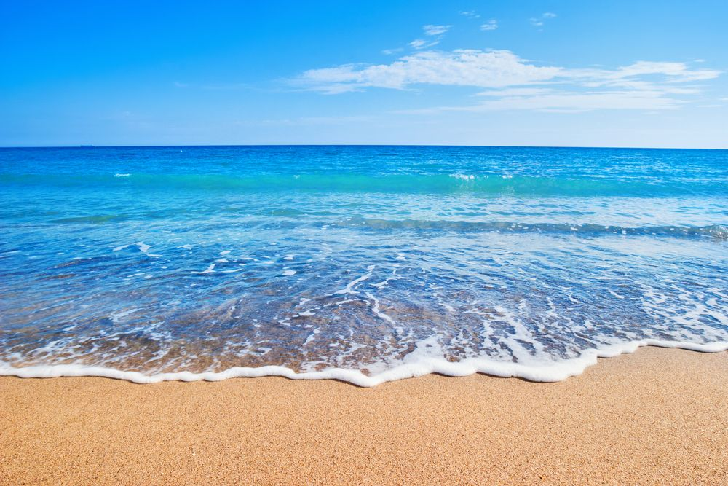

Blue room - Ocean, calm, peaceful, player should feel relaxed. Maybe the sound of waves rushing by, interact with friendly creatures, fish and their habitats, if walking into water, no fear of wondering what is below you, it is well lit and shallow, sandcastle creation is an option on the beach

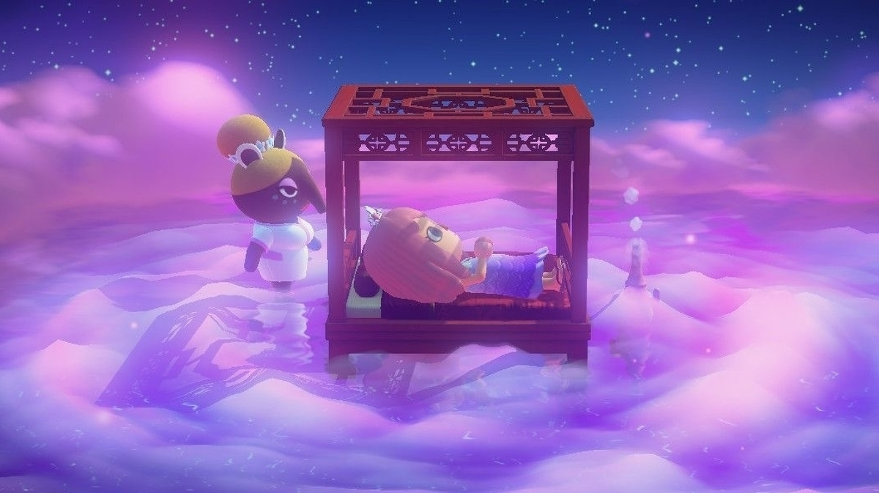

Violet room - Purple sand with glitter and sparkling dust gives off a very magical and peaceful mood.

b. List at least 3 images for objects that will be in your environment

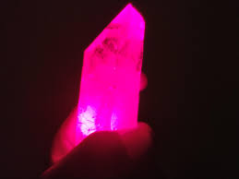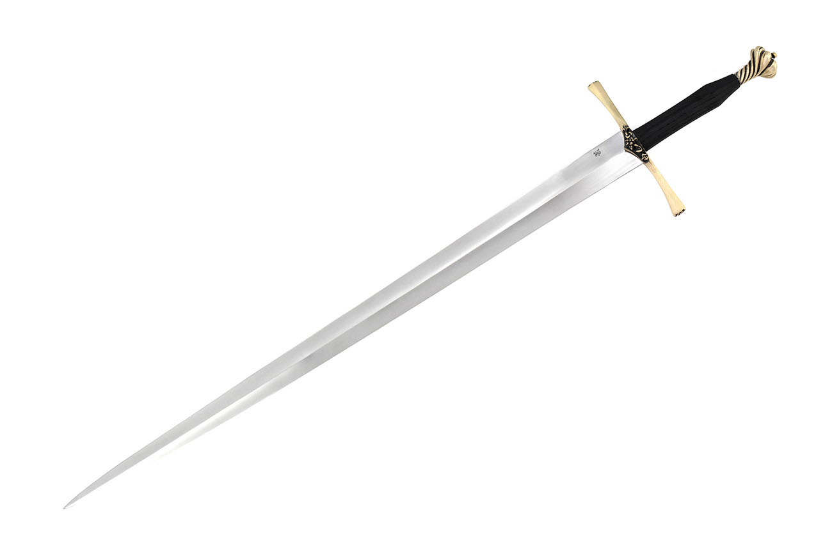

Crystal - A representation of what a crystal from the battle room might look like. Sword - Present in the battle room, perhaps both fake and real are present.

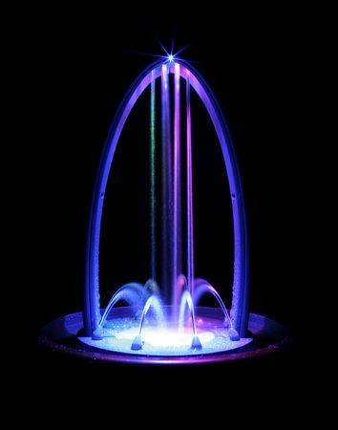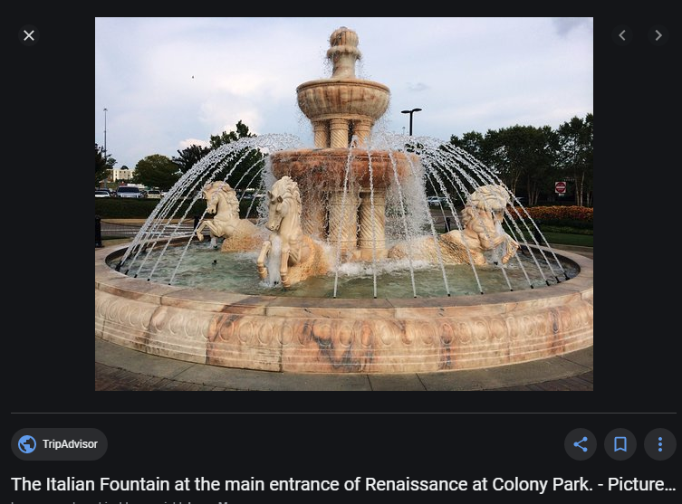

Fountain/s - Gives an idea of what the fountain in the middle of the room might look like

c. Give a brief description of how your images relate to the design objectives and themes ( a couple of sentences)

* There are detailed descriptions below each image to show why we chose those images and how they align with the design objectives.

Notes/Resources:

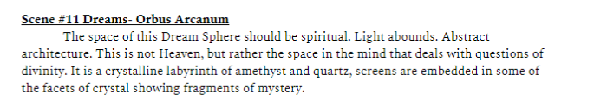

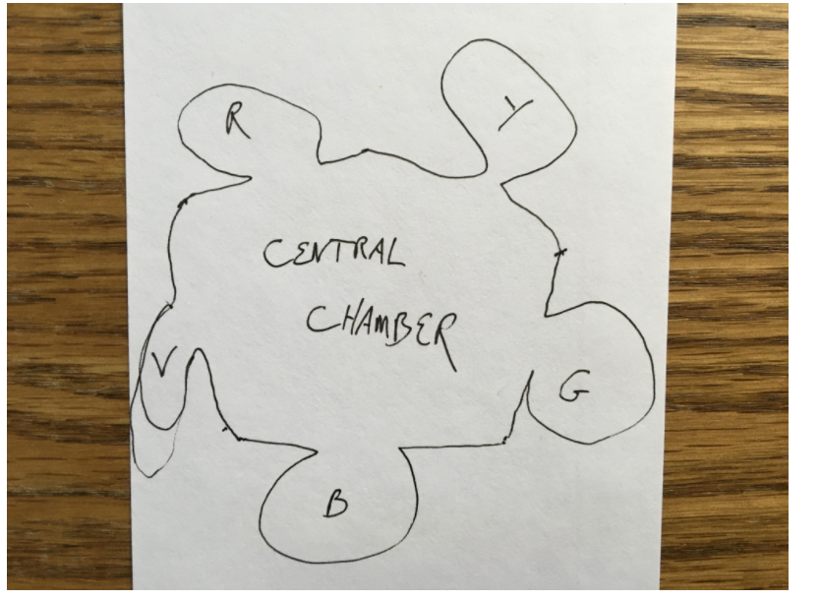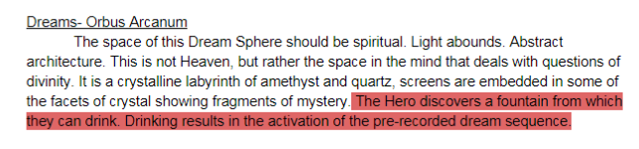

A lofty cavern made of crystal. Something that looks like rose quartz. As the space rises we see abstract architecture, strong angular buttresses that support a domed ceiling.

The attached picture is the top view of the cavern. Five smaller chambers are accessible off the main room, each themed by color, each dedicated to a certain kind of dream, and filled with objects and images that have an interactive element. Each room can have its own soundscape that is faded in when the audience walks into that space.

Red: The room of battle dreams. Swords, golden treasures, Blood, Victory.

Yellow: The room of flying dreams. Exciting and adrenaline inducing. Can we embed a screen in the floor to make it seem that we are suspended high above a landscape?

Green: Forest Dreams. Calm but suspenseful. We should have the impression that we are hunting or being hunted.

Blue: The room of Ocean dreams. Peaceful and calming. Let’s use a video screen of the ocean to make us feel like we are gazing out to sea.

And Violet: Dreams of Prophecy. Amethyst Crystals with vague images embedded in them. Perhaps they are labeled in a mysterious way.

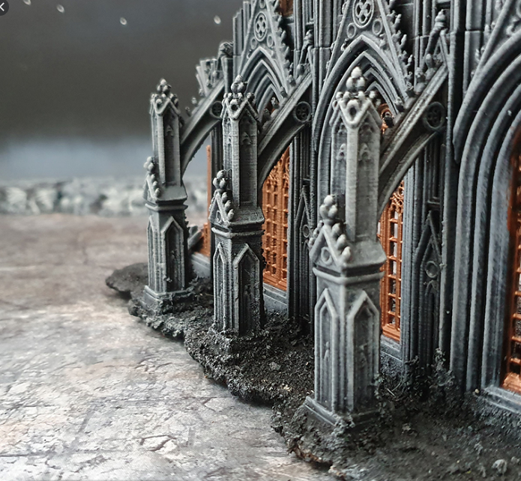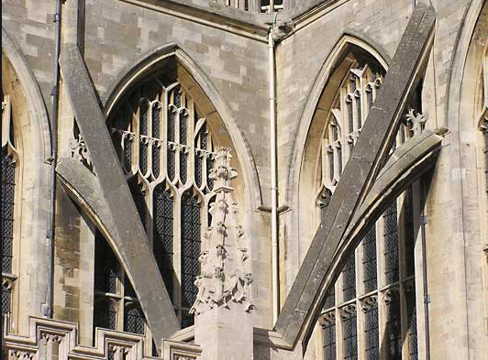

<https://www.bypost.com/blog/caves> mixture of caves 1, 2, 3, 5, 7, 12 + luminous crystal supports is my vision

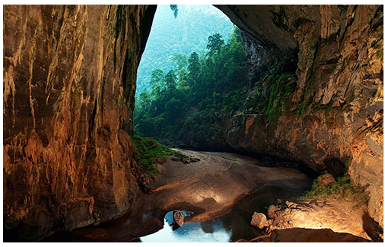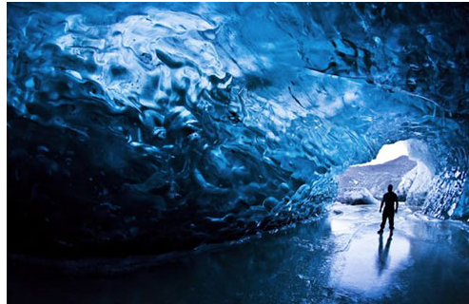

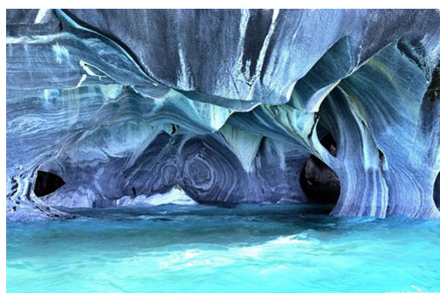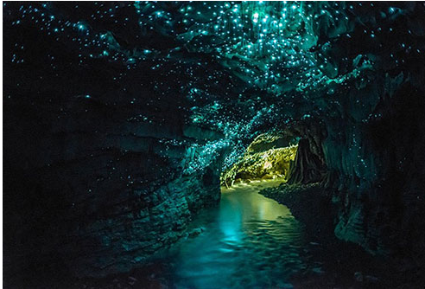

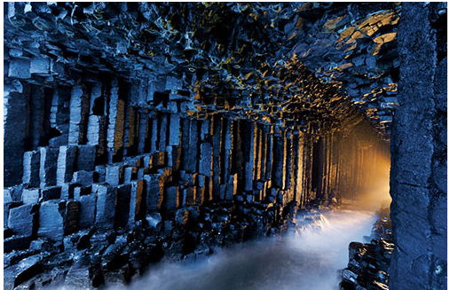

Maybe the lights in the cave pulsing = hero’s heartbeat? When he drinks red, pulsing gets quicker but has negative undertone, yellow it would be positive undertone, green it would go slow then quick, blue is calm peaceful and in rhythm, violet is slow. Not like strobe lights, instead like veins in the walls, whatever you drink pumps through it, but not in an alarming way, submissive colors that illuminate, not spotlights. Pulsing through preset veins in the cavern, like maybe some would think they were wires.

Anyway, yeah i was hoping we could combine the cave/castle, add some parts from both. Mainly, I like the marble cave, spacious and lofty but looks like it has some sort of architecture, maybe organize the cave like one of the dr suess ways to see things. Also, what if after you explore a new room, the main room changes to be something different? Like, at arrival, main room is empty, then it looks like og cockpit hero flew in, slowly it turns into the living room he met his uncle in, then the lab, then the somnium inside where he is, then he wakes up by automatically going into the seat - like maybe how some things choose us? 5 different places for it to resemble. After each new spot explored, main room decor changes to the next sequence. No going back to experience rooms again (?) Maybe the decor or screens, but i think decor makes more of an impact, and on the screen it can be really blurry scenes from the game, positioned somewhere in the decor - tv of living room, radar of cockpit, some screen on somnium, computer in the lab. Shows how your experiences, emotions, and the way you build what happens in your mind?

Also, I don’t think the screens should be literal rectangles in the walls for the ones around the castle - maybe replace shards with screens, have some only static, have others moving pictures.

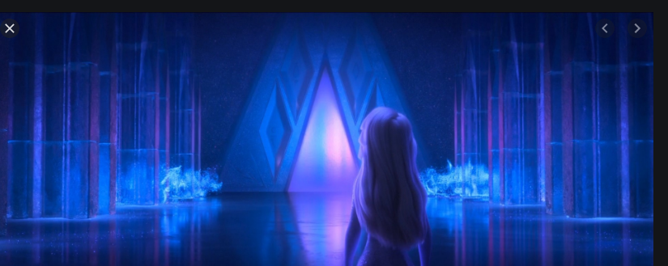

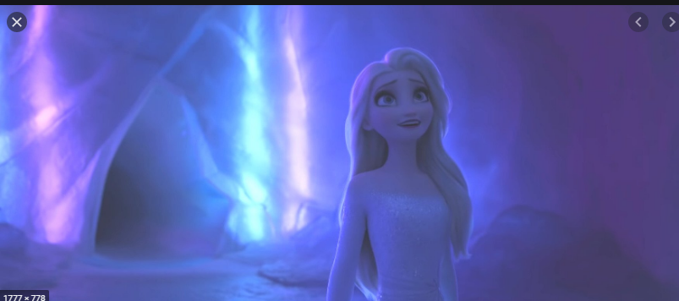

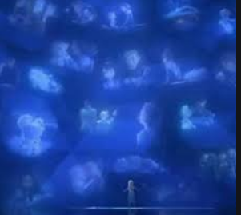 ok, i think client wants frozen 2 or maybe i want frozen 2 but like crystal screens??? Cavern AND castle???